Grazioso Salvare: CRUD Python Module

Purpose

The purpose of this Python module is to interface with a MongoDB database to perform CRUD (Create, Read, Update, Delete) operations on data regarding dogs in an animal shelter. The module enables the insertion, retrieval, modification, and removal of documents in the database that stores details about dogs suitable for search-and-rescue training.

Requirements

Python 3.x: Ensure Python 3.x is installed.

pymongo: The MongoDB Python driver, used for interacting with MongoDB.

You can install pymongo using pip:

pip install pymongo

MongoDB Driver

pymongo

We are using the official Python MongoDB driver, pymongo. This library provides tools for working with MongoDB, such as connecting to a MongoDB instance, querying, and modifying documents. It is chosen because of its widespread use and comprehensive support for all MongoDB operations in Python.

How to Use the CRUD Module

1. Install the Module

Download the crud.py file and place it in your project folder.

2. Connect to the Database

The module connects to a MongoDB instance hosted on localhost at port 22804. You must specify the database and collection names when instantiating the CRUD class. You also need to provide authentication credentials.

Example of how to instantiate the CRUD class:

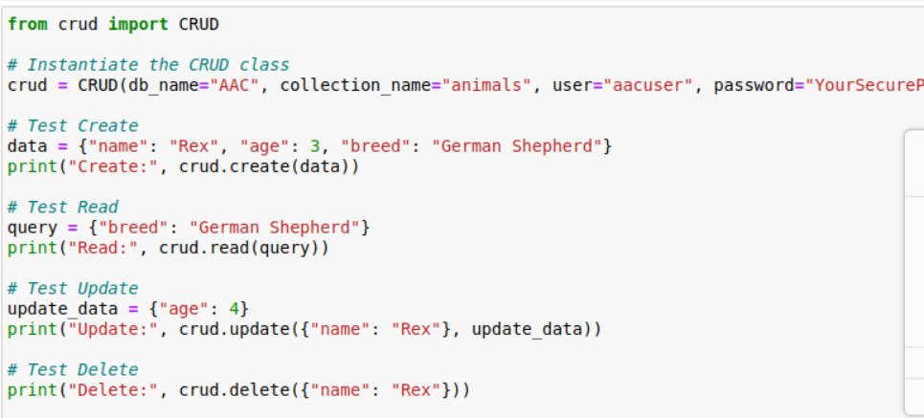

3. CRUD Operations

Create Operation

The create method inserts a document into the collection.

Read Operation

The read method retrieves documents based on a query.

Update Operation

The update method modifies documents based on a query.

Delete Operation

The delete method removes documents based on a query.  
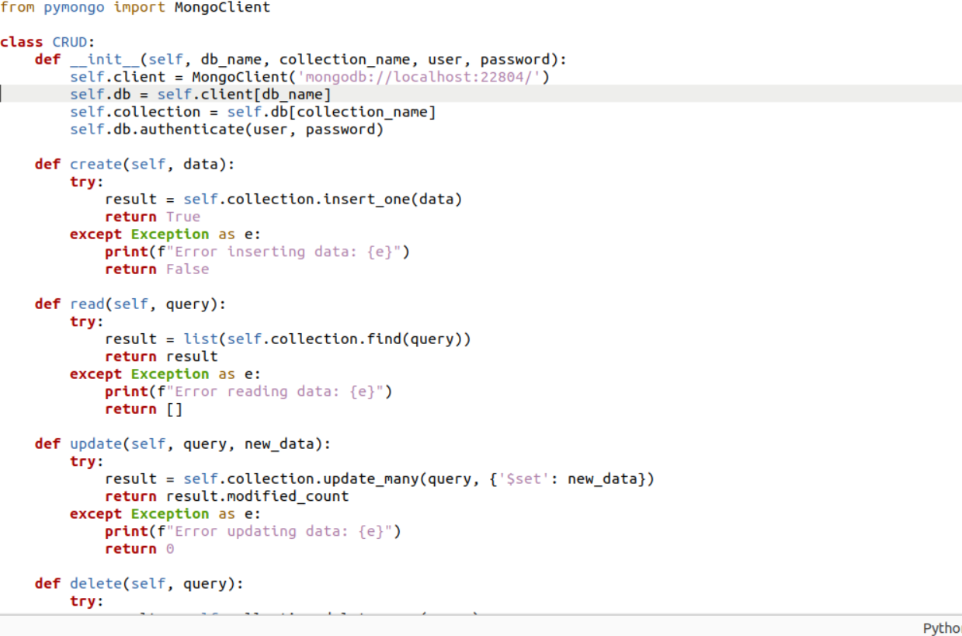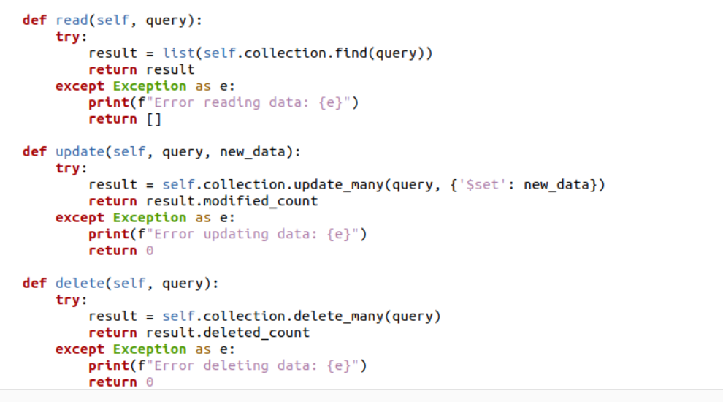

Testing the CRUD Operations

You can test the CRUD functionality using a separate Python script (test_crud.py). Below is an example of how you can test each CRUD operation:

After running this script, the operations will be executed, and you can verify the results in the MongoDB database.

Screenshots

Include the following screenshots to demonstrate key steps in the project:

1. MongoDB Import Execution

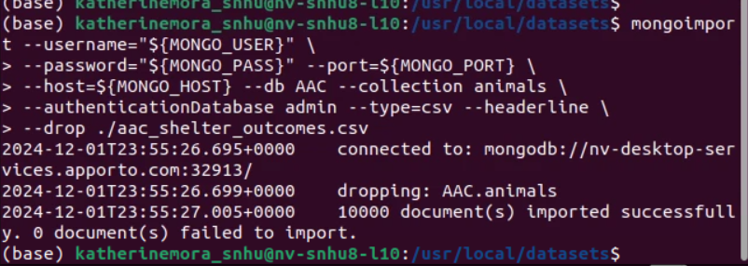

2. User Authentication Execution

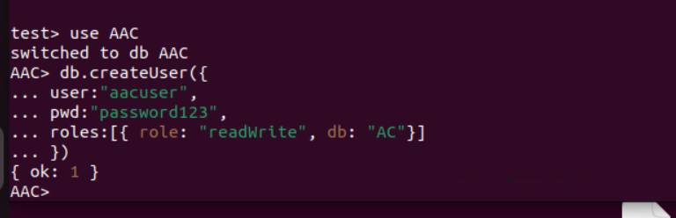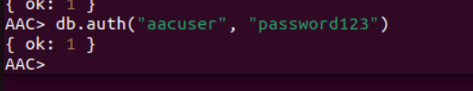

3. CRUD Functionality Test Execution

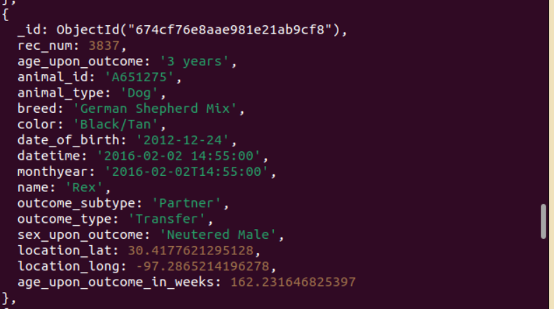

Conclusion

This CRUD Python module provides an easy interface for managing documents in the MongoDB database related to dogs at the animal shelter. It supports basic CRUD operations for inserting, querying, updating, and deleting data, and it can be easily integrated into larger applications.